**KAMPALA URBAN SCHOOLS**

**BEGINNING OF FEBRUARY EXAMINATIONS, 2024**

**PRIMARY FIVE MATHEMATICS**

**NAME:_________________________________________STREAM: _______**

**SECTION: A (40 MARKS)**

1. Multiply: 15 ÷ 3 =
2. Write in figures. “One hundred thirty three.”
3. 8plates + 5plates + 2plates = ____plates
4. Shade R U H in the Venn diagram below.

H

R

1. How many days are in 7weeks?
2. MrOkello has 4 coins of shs500 each. How much money does he have?
3. Find the LCM of 4 and 3
4. If the radius of a circle is 4cm. Find its diameter.
5. Add: 5/11+ 1/11 =
6. Set P = {Days of the week}. How many members are in set P?
7. A kilogram of salt costs shs 1200. How much will you pay for 4kilograms of the same salt?
8. Subtract : 790 - 325
9. Express 800cm as metres.
10. Find the next number in the series.

1, 2, 4, 8, 16, ___

1. Buloba had 172goats. He sold 62 of them, how many did he remain with?
2. Name this geometrical shape.
3. Find the area of the shape below

9cm

18. Shade ¾ of the diagram below

|  |  |
| --- | --- |
|  |  |
|  |  |

19. Circle the largest number

18, 28, 1.8, 81, 78.

20. Write down the time shown on the clock face below.

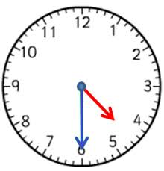

**SECTION: B (60 MARKS)**

21. Set T= {1, 2, 3, 4, 5, 6} and set R = {2, 4, 6, 7, 8}.

a) Find T Ո R = (2 marks each)

b) Write down members of set T only.

c) Represent the members of TUR on the Venn diagram below

T

R

22. There are 25 mangoes in a basket. 3/5 are ripe and the rest are raw.

a) How many mangoes are in the basket? (2 marks each)

b) Find the fraction of mangoes that are raw.

c) How many ripe mangoes are in the basket?

23. Work out: (2 marks each)

a) Wks Daysb) HrsMins

5 55

5 4

- 4 45

+ 4 2

24. Solve the following equations.

i) x + 6 = 17 ii) p – 7 = 20 ( 2 markseach)

iii)yx3=18

25. Below is a price lists in Robert’s shop. Use it to answer the questions that follow.

|  |  |
| --- | --- |
| **Item** | **Price** |
| Omo | Shs 500 a sachet |
| Blue band | Shs 3500 a tin |
| Salt | Shs1200 a kg |
| Sugar | Shs 4500 a kg |
| Book | Shs 1000 each |

1. Name the cheapest item on the above list. (2 marks each)
2. How much money will you pay for omo and blue band?
3. If you bought a kilogram of sugar, salt and a book. How much money would you pay?

26. Study the graph below about Eva’s performance in mid-term and answer the questions that follow.

|  |  |  |  |  |
| --- | --- | --- | --- | --- |
| **Subject** | Maths | English | Social Studies | Science |
| **Mark** | 93 | 90 | 91 | 96 |

1. In which subject did she score the highest mark? (2 marks each)
2. If a score for D1 was 95 and above, which subject did she miss a D1 by two marks?
3. What was Eva’s total marks?

27. Use the number 2357 to answer the questions that follow.

a) What is the place value of 2 in the number above? (2 marks each)

b) Find the value of 3 in the number above.

c) Write the number above in words.

28. Faisal is 16 years old. Jude is 10 years old.

a) Who is older? (2 marks each)

b) Find their total age.

29. With a sharp pencil, a ruler, draw the following geometrical shapes.

a) A kite b) A cylinder

_______________ _______________(2marks each)

30. Complete the table below.

|  |  |  |  |  |  |  |  |
| --- | --- | --- | --- | --- | --- | --- | --- |
| **Years** | 1 | ____ | 4 | 6 | ____ | 9 | 10 |
| **Months** | 12 | 24 | _____ | 72 | 96 | 108 | ____ |

(1mark each)

31. a) In a village there are 453men and 618women. How many adults are in that village? (2 marks each)

b) In a stream, there are 35pupils. If each pupils is given 4 exercise books, how many books were given out?

32. The graph below shows how a primary four class planted seedlings in the school. One seedling represents 2seedlings.

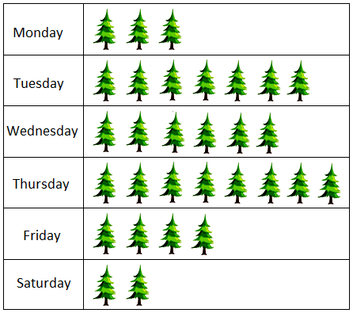

a) How many seedlings were planted on Tuesday? **(1mark)**

b) Which day did they plant the highest number of seedlings? **(1mark)**

c) How many seedlings were planted on Friday and Saturday? **(2marks)**